3-21-22

March Greens Update

Golf course update

Grinding and cleanup of the stumps left from this winter’s work is complete. Now we will wait for appropriate weather to seed and or sod these areas.

The turf handled the winter months with no signs of injury or desiccation. The putting greens are ‘greener’ than the other grasses because of a heavy sand topdressing application made in December. This is to ensure even in the harshest of winters the crown of the plant will stay insulated and protected from potential winter kill. It also aides in spring green up as you can see now.

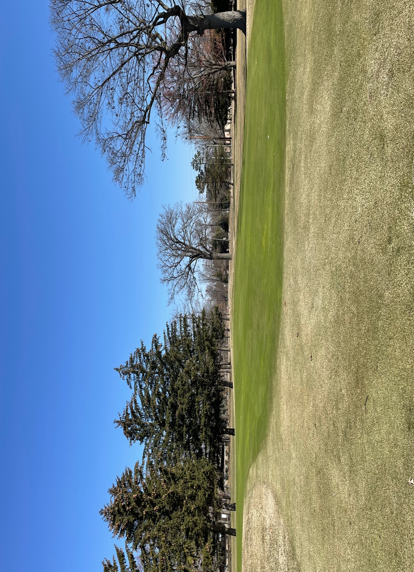
Putting Green construction is underway with a planned seeding and sod timing of early May. Native area conversions will begin soon, areas will be roped off to indicate they are off limits until grasses are established.

Recommend opening greens this weekend. With Carts to be allowed at a TBD date.

